Auto Ticket Classification Using Flow Designer
The Auto Ticket Classification process is implemented using ServiceNow Flow Designer to automatically classify IT support tickets based on the issue description provided by the student.
When a student creates a new IT support ticket, the student is required to enter only the Caller Name and Short Description of the issue. The Category and Subcategory fields do not need to be selected manually.
After the ticket is submitted, a Flow Designer flow is triggered automatically. The flow evaluates the Short Description and checks for predefined keywords associated with common IT support issues. Based on the keyword identified, the flow automatically updates the ticket with the corresponding Category and Subcategory.
The classification rules are configured as follows:
Keyword | Category | Subcategory
WiFi | Network | WiFi
Projector | Hardware | Projector
Password / Login | Access | Forgot Password
Slow / Hanging | Performance | Slow Computer
For example, when the Short Description contains the keyword “WiFi”, the flow identifies it as a network-related issue and automatically assigns Category = Network and Subcategory = WiFi.
Similarly, when the description contains “Projector”, the ticket is classified under Category = Hardware and Subcategory = Projector. If the description contains “Password” or “Login”, the flow assigns Category = Access and Subcategory = Forgot Password. For descriptions containing “Slow” or “Hanging”, the ticket is assigned Category = Performance and Subcategory = Slow Computer.
The overall process can be represented as:
Ticket Creation → Flow Trigger → Keyword Identification → Condition Evaluation → Category & Subcategory Assignment → Classified Ticket
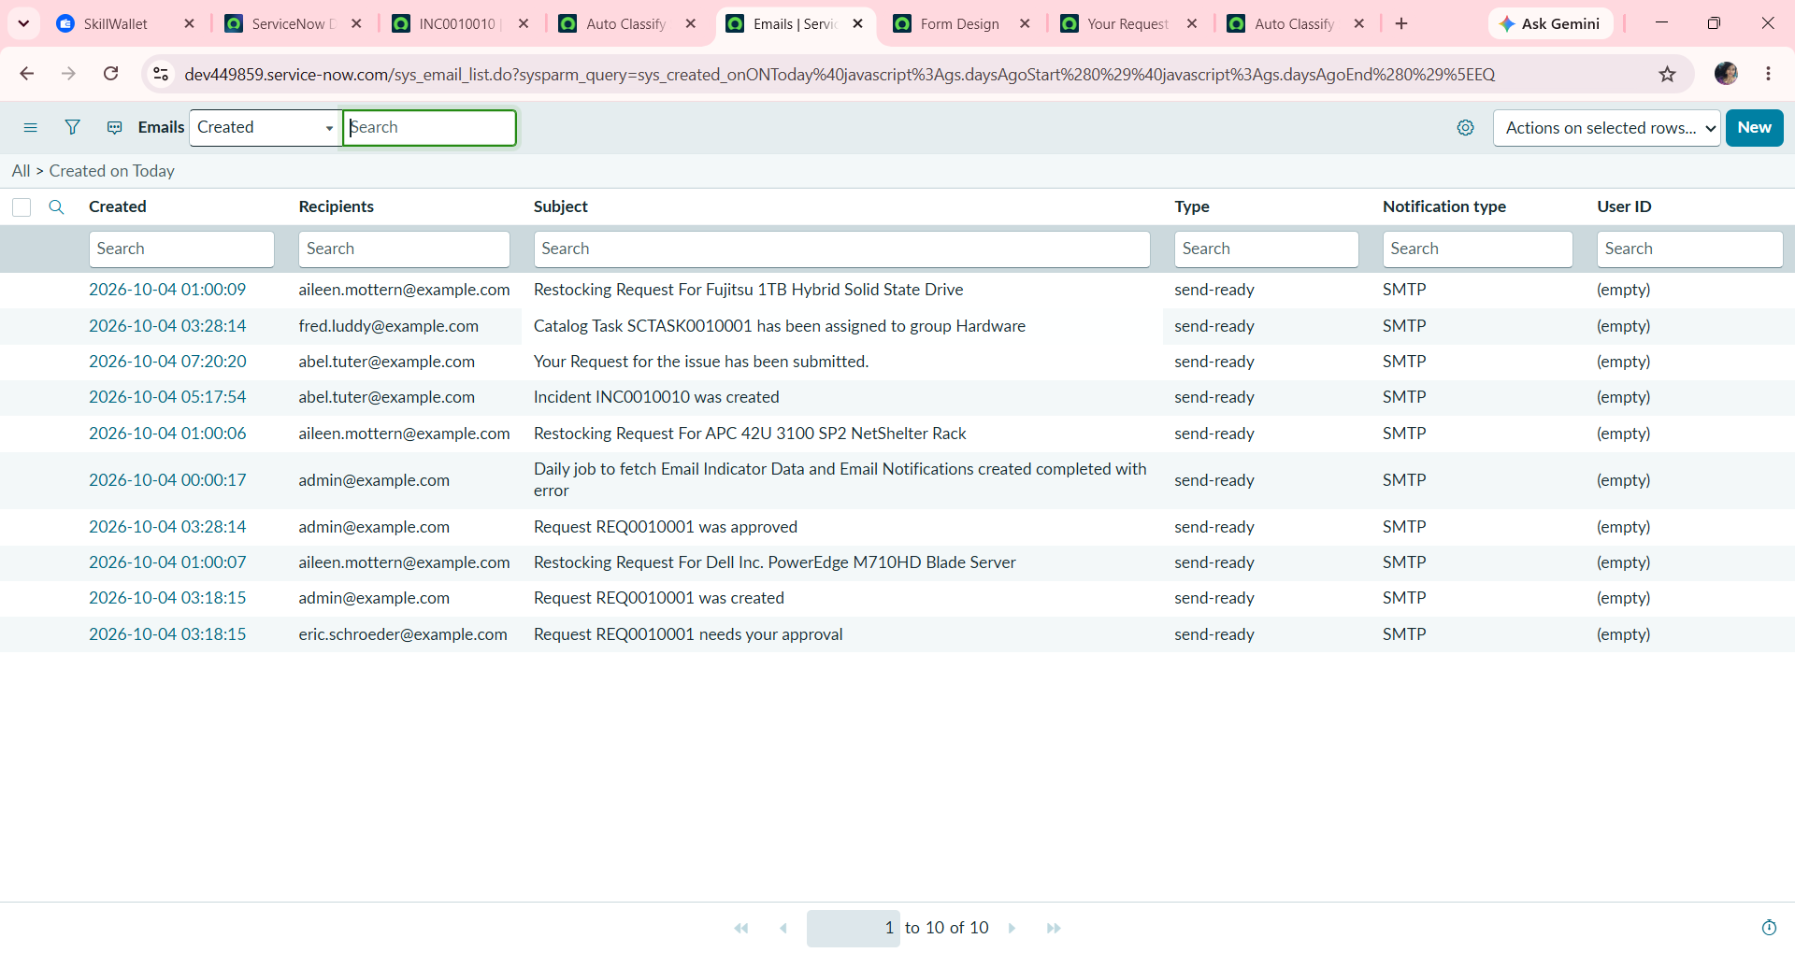
This automation provides consistent ticket classification and reduces the need for manual intervention by IT staff. It also minimizes classification errors and improves the efficiency of the helpdesk process. Since the automation is implemented using Flow Designer, the classification rules can be maintained and extended easily by adding new conditions and categories as required.
Activity : 1 Auto Classification using Flow design.

- Go to All menus → Search Flow designer.
- Under Process Automation Open the Flow designer.
- On the top right corner Click New and Select Flow Option.
- Name : Auto Classify School IT Tickets.
- Application : Global.
- Now Click the Build Flow button.

Activity : 2 Trigger Configuration.

- Trigger : Record Created.
- Table : Incident Workflow.
- Condition : Category is Empty.
- Then Click Done.
- Now Under Actions Select Flow Logic Option.

Activity : 3 Wi-Fi Issue Classification.

- Select If condition.
- Condition label : SD is Wifi or Network (Give as ur wish).
- Condition 1 : Using data pill picker Select Short description as Field , and operator Contains , Value is Wi-Fi.
- Condition 2 : Using data pill picker Select Short description as Field, and Operator is Contains, Value is Network.
- Then Click Done Button.
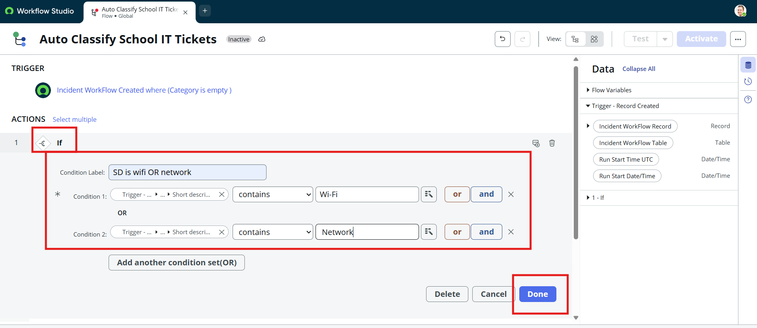
- Now Click Action to Update record.
- Action Inputs.
- In Record Field drag and drop data from the right side.
- Table : Auto updates as Incident Workflow.
- Fields Set Category = Network.
- Set Subcategory = Wi-Fi.
- Then Click the Done button.
Activity : 4 Projector Issue Classification.

- Now Select the Else If Condition.
- Condition label : SD is Projector or Hardware.
- Condition : Short description Contains Prajector.
- Then Click the Done button.
- Now Action is an Update record.
- Set Category = Hardware.
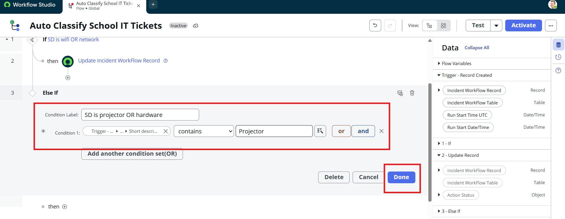
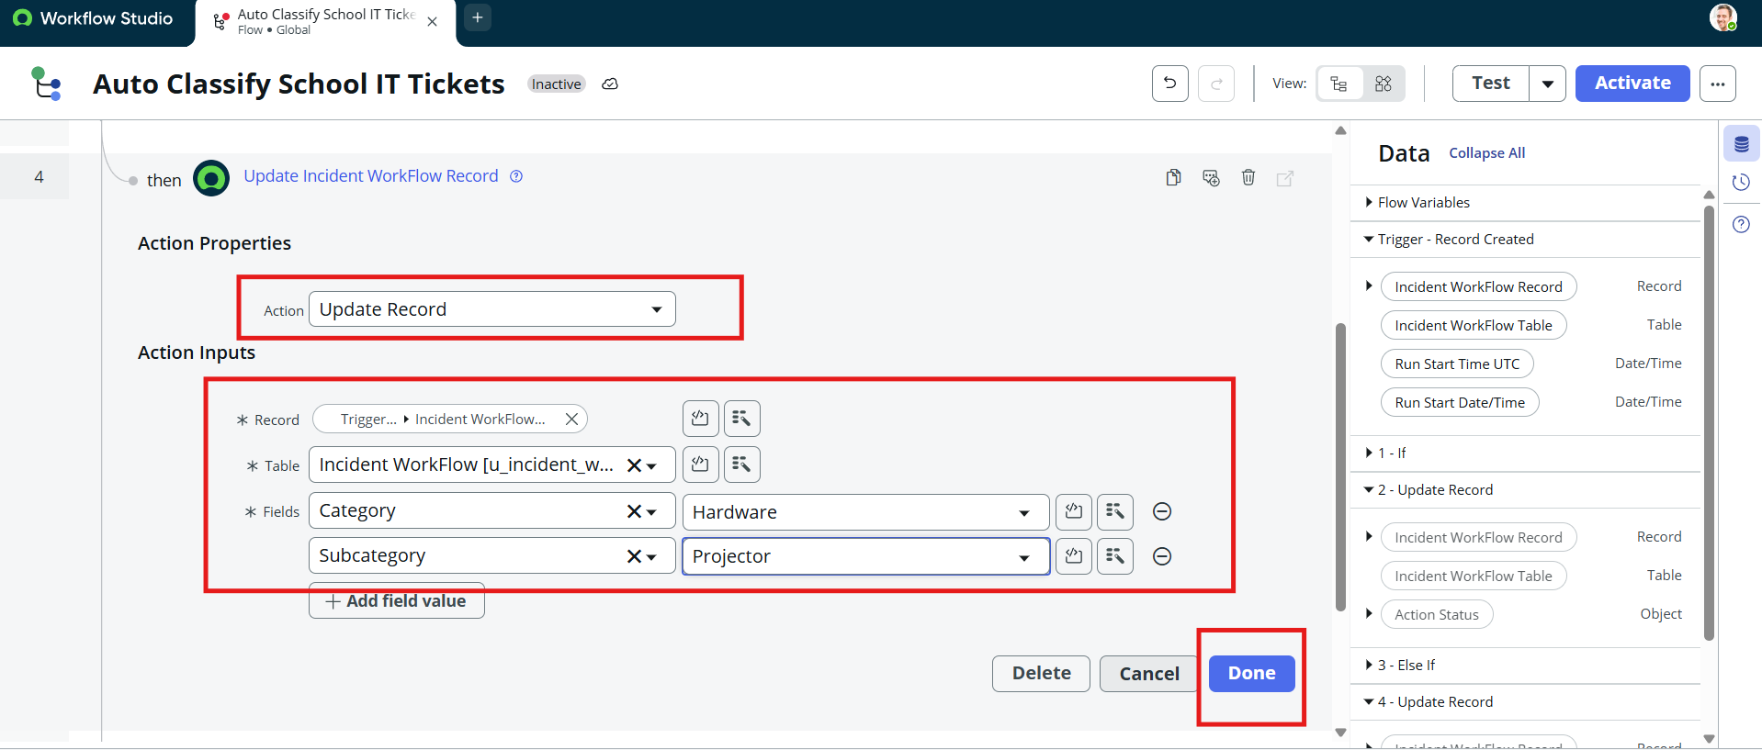
- Set Subcategory = Projector
- Then click done button.

Activity : 5 Password Issue Classification.

- Now again select Else If condition.
- Condition label : SD is Forgot password.
- Condition : Short description contains Forgot password.
- Then Click the Done button.
- Now Action is an Update Record.
- Set Category = Access.
- Set Subcategory = Forgot Password.
- If it doesnt have forgot password option, you can simply give “none’’
- Then Click the Done button.
Activity : 6 Slow Computer Classification.

- Now Again Click the Else If Condition.
- Condition label : SD is Performance.
- Condition : Short description contains Slow Computer.
- Then Click the Done button.
- Now Action is an Update Record.
- Set Category = Performance.
- Set Subcategory = Slow computer.
- Then Click the Done button.

Activity : 7 Email Action Setup.

- After classification, an email notification is sent using Flow Designer.
- Set Action Send Email.
- To : Caller → Email.
- Subject : Your Request for the issue has been submitted.
- Body : Ticket confirmation message.
- Then Click the Done button.
- Then click the activate button.

